DE YOUNGSTERS INTERNATIONAL SCHOOL
FIRST MOCK EXAMINATION FEBRUARY, 2021

NAME: …………………………………………………..INDEX NO:……………………….
(BDT) PRE-TECHNICAL SKILLS TIME: 1 HOUR 45 MINUTES
PAPER 2 SECTION A
CORE SKILLS [ 20 marks ] ANSWER QUESTION 1
[ COMPUSORY ]
(1) (a) State one advantage of baked foods 2 Marks
(b) State one major function of each of the following nutrients in children:
(i) carbohydrate 1 mark
(ii) Vitamins 1 mark
(c) (i) Define exhibition 2 marks
(ii) Give two reasons why artworks are exhibited 2 marks
(iii) List two types of exhibition 2 marks
(iv) State one major difference between the two types of exhibition
1 mark
(d) (i) List two stages of the design process 2 marks
(ii) List two methods of recording information for solving a design problem
2 marks
(iii) Name a suitable pencil for sketching a possible solution in a design
work. 1 mark
(iv) List three methods of pictorial drawing 3 marks
(v) Define a line 1 mark
SECTION ‘B’
[ 50marks ]
ANSWER two questions from this section
All questions carry equal marks.
2. (a) ( I) State two causes of accidents when using hand tools in the workshop
(ii) List four personal safety clothings used by a craftsman
(b) (I) State two grades of abrasive materials
(ii) List four types of measuring tools used in blockwork
(c) Figure 1 shows a sketch of a wooden joint. Use it to answer questions 2(c) (i) to (iv)
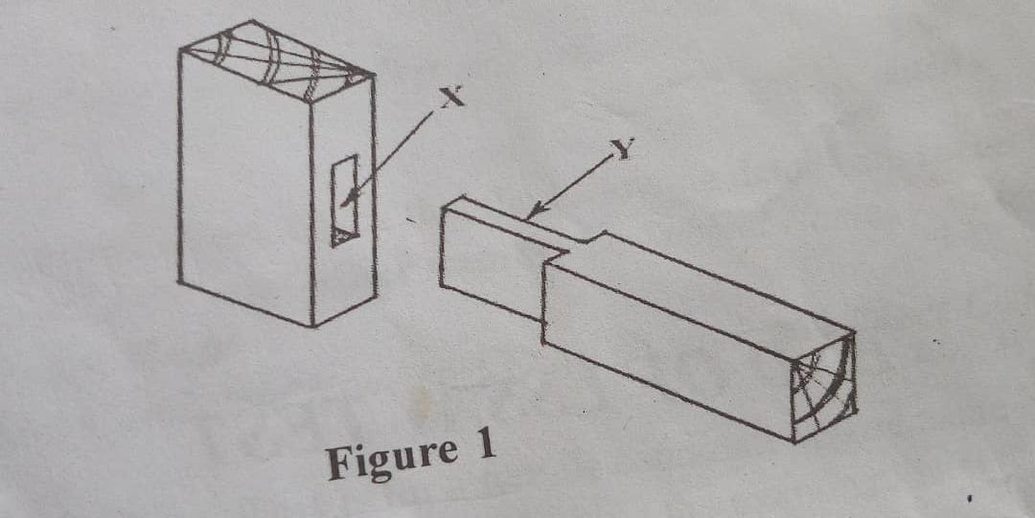
(i)Name the type of joint shown
(ii). Identify the parts labelled X and Y
(Iii). List two types of adhesive materials that can be used to
Strengthen the joint.
iv. List three specific tools used for preparing the joint [ 25marks ]

3. (a) (i). State the difference between a brick and a block
(ii). List two materials used for moulding a block Pg 1
(iii). List three tools used for moulding sandcrete blocks
(b) State one use of each of the following materials:
(i). aluminium
(ii). Copper
(c) List two tools used in each of the following operations in woodwork:
(i). Preparing a smooth wooden surface
(ii). holding a woodwork piece firmly on a bench
(d).(i) Make a freehand pictorial sketch of the triangular file.
(ii). Label the following parts on the sketch in question 3(d)(i):
a) handle
b) tang
c) blade
[ 25 marks ]
4. (a) Explain the following terms:
(i). Pinning
(ii). Curing
(b). State one use each of the following measuring tools:
(i) steel rule
(ii) tape measure
(C). Copy and complete the table below.
Process | One tool used
Plumbing a wall
(ii) checking corners of a wall
(iii) measuring aggregates
(iv) checking courses of a wall
(v) picking and spreading mortar
(vi) mixing mortar

(d).(i) Make a freehand sketch of a hacksaw.
(ii). Label any two parts of the sketch in (d) (i)
[ 25 marks ]

Pg 2
PAPER ONE
Answers all the questions
1.Causing of food spoilage may be attributed to the following reasons except
A. improper harvesting methods B. Insect and rodent attack
C. Natural decay within the food D. Contamination by bacterial
2. Conspicuous seams are those that are
A. Easily noticed on the right side of a garment B. Made with the turning pressed to one side
C. Cannot be seen on the right side D. Easy to make
3. Protective foods include
A. Cassava and plantain B. Oily seeds and pulses C. Plantain and cocoyam D. Vegetables and fruits
4. Which of the following is NOT a risk?
A. theft B. Flooding C. Fire outbreak D. Low quality of product
5. The main outline of a drawing is shown with
A. Continuous thin lines B. Continuous thick lines C. Broken lines D. Hatching lines.
6. Rhythm, variety, harmony and contrast in designing are termed
A. element B. Principles C. Ideas D. Values
7. The colour code for an earth wire is
A. Pink B. Red C. Brown D. Yellow
8. The position of the plan in third angle projection is
A. below the front elevation B. Above the front elevation
C. Left side of the front elevation D. right side of the front elevation
9. The statement that specifies a need is
A. brief B. Situation C. analysis D. Investigation
10. Prisms and pyramids can be best be named according to the
A. base B. Vertex C. Face D. Edge
11. Missing nails in household furniture occur in
A. Concrete benches B. Metal tables C. Plastic cabinet D. Wooden chairs
12. The stage in designing where the strengths and weaknesses of an artefact are assessed is known as
A. evaluation B. Analysis C. Investigation D. Final solution
13. A formal outlet for raising money to start a sewing business is
A. a family member B. A rural bank C. money lenders D. The susuman.
14. In drawing, objects nearer the viewer are in the
A. background B. Foreground C. Horizon D. Middle ground
15. Pencils for drawing are sharpened to
A. square and chisel edge B. Trapezoid and spherical points
C. Conical and chisel points D. spherical and conical points
16. Which of the following gives the position of the bubble in a spirit level when a wall is straight?
A. Left end B. Right end C. Out of view D. Centre
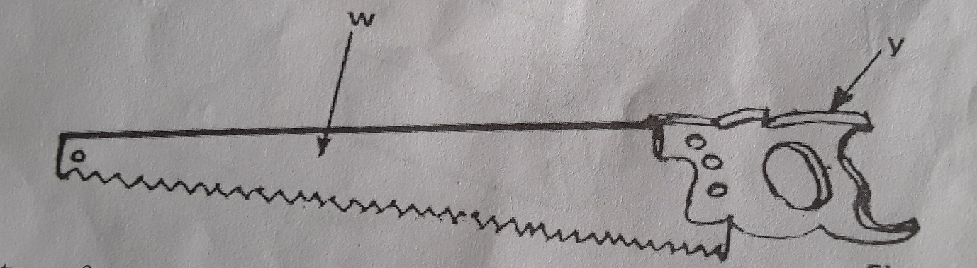
Use Figure 2 to answer questions 17 and 18.

Figure 2
17. The type of saw shown in figure 2 is a
A. Crosscut saw B. Dovetail saw C. Hacksaw D. Tenon saw
18. The suitable fastener used for joining the parts labelled W and Y together is
A. bolt B. nails C. rivet D. Screw.
19. Which of the following is the most suitable tool for removing unwanted parts of wood?
A. Flat chisel B. Mortise chisel C. Mortise gauge D. Hacksaw
20. One property of a good mortar is its ability to
A. remix easily B. Remould easily C. Spread easily D. Set slowly
21. The most suitable plastic for making water – pipe is
A. Acrylic B. Polythene C. Epoxy resin D. Polyvinyl chloride
22. The views shown below are represented in
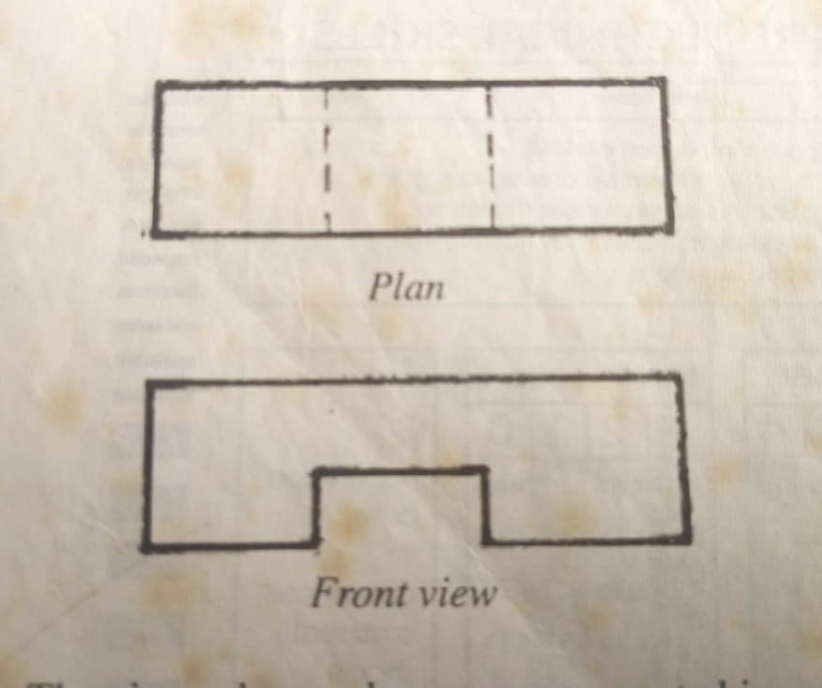

A. Oblique drawing B. Isometric drawing C. First Angle Projection D. Third angle projection
23. Polyvinyl acetate is a type of
A. Aggregate B. Adhesive C. Abrasive D. Finish
24. Soft solder is mainly an alloy of
A. Tin and lead B. Tin and zinc C. Copper and tin D. Copper and zinc
25. The process of making mortar compact in a mould box is known as
A. batching B. Pounding C. Pressing D. Tamping
26. Which of the following is not a fastener?
A. Rivet B. Screws C. Soldering bit D. Bolts and not
27. Electrical appliances are usually plugged to the electricity mains through
A, switches B. Lamp holders C. Socket outlets D. Ceiling rose
28. The operation shown in the sketch below is
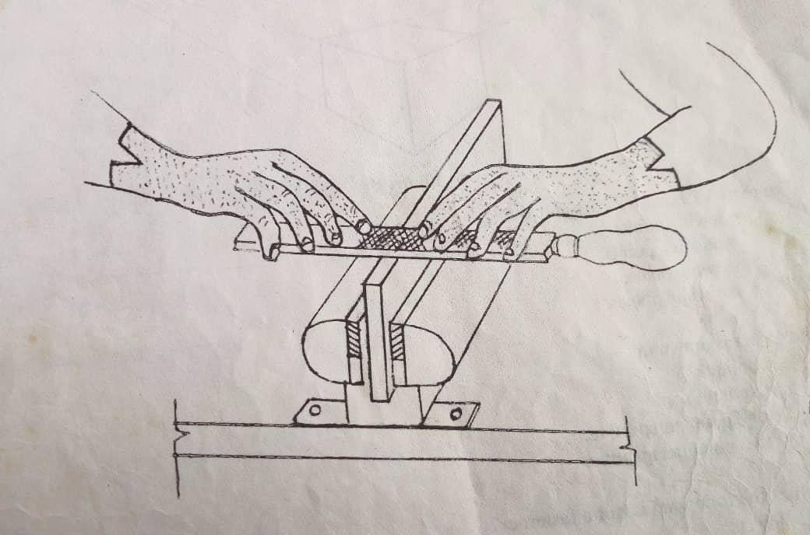
A. Cross filing B. Draw filing C. Smooth filing D. Rough filing
29. Which of the following is a physical property of metals?
A. Weight B. Brittleness C. Ductility D. Malleability
30. One purpose of using flux in soldering is to
A. Prevent formation of oxide B. Wash surfaces of the work
C. heat the soldering iron D. Make the joint neat

END OF PAPER

Pg 3

