DE YOUNGESTER'S INTERNATIONAL SCHOOL
FIRST MOCK EXAMINATION- FEBRUARY,2021
INTEGRATED SCIENCE TIME: 2 HOURS

NAME: ………………………………………………..INDEX NO:…………………………….
PAPER TWO 1 hour 15 minutes
ESSAY [100 marks]
This section is in two parts, I and II
Answer Question 1 of Part I and any other four questions in Part II.
Credit will be given for clarity of expression and orderly presentation of material
PART I [40 marks]
(Compulsory – Answer all of Question 1)
1. (a) Study the simple circuit diagram shown below and answer the questions that follow
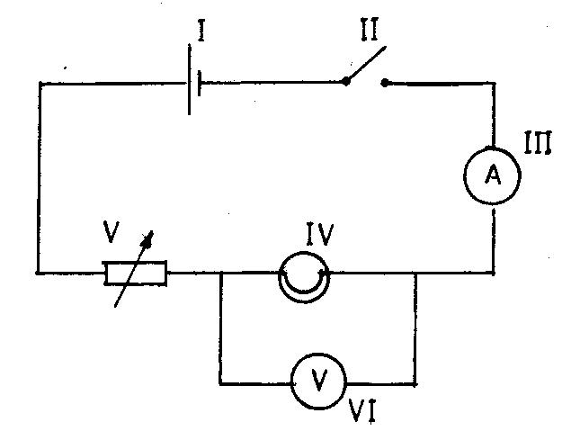

(i) Identify the components labelled I, II, III, IV, V, VI
(ii) Which component is used to close the circuit?
(iii) State the observation that will be made when the circuit is closed.
(iv) State the energy transformations that take place when the circuit is closed
(v) Give the name of the circuit connection between components IV, VI [10 marks]

(b) The diagram below is an illustration of an experimental set-up used for separating a mixture of water and alcohol. Study the diagram carefully and answer the questions that follow.
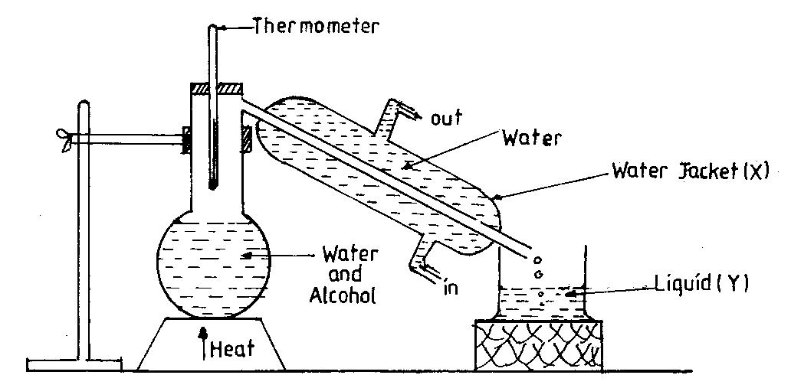

(i) State the method of separation shown in the set-up
(ii) Identify liquid Y, with reasons. Pg 1
(iii) Give the functions of the thermometer and the water jacket X
(iv) What physical processes are involved in the method of separating the mixture?
(v) State the physical property which makes it possible to separate the water and alcohol [10 marks]

(c) A student performed tests on food substances A, B and C and made the following observations

Food Substance | Test | Observation
A | Few drops of iodine solution was added to A | The iodine solution turns blue-black
B | A drop of B was applied to a white sheet of paper | A translucent patch was seen on the paper
C | Benedict’s solution was added to C and the mixture boiled | Benedicts’s solution turns from blue to brick-red

(i) Identify food substances A, B and C.
(ii) Give the products of digestion of A, B and C
(iii) In which parts of the alimentary canal does the digestion of each of food substances A, B and C start?
(iv) In which part of the alimentary canal is food substance C absorbed after digestion? [10 marks]

(d) The diagram below is an illustration of a simple farm tool.
Study it carefully and use it to answer the questions that follow:
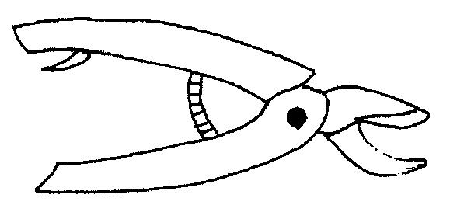

(i) Identify the tool
(ii) State three uses of the tool
(iii) Mention three ways of maintaining the tool [10 marks]

[60 marks]
Answer four questions only from this section.
Illustrate your answers wherever possible, with large, clear and fully labelled diagrams.
Credit will be given for clarity of expression and orderly presentation of material.
All questions carry equal marks

2. (a) (i) Define pressure.
(ii) Explain why it is important to sharpen a knife before use

(b) (i) State two differences between metals and non-metals
(ii) What is an alloy?
(iii) Mention the components of each of the following alloys:
(α) steel
(β) brass

Pg 2

(c) (i) Explain the term vegetative propagation.
(ii) Give any two examples of plants that reproduce vegetatively.

3. (a) Define the following terms and give one example of each:
(i) Compound (ii) Mixture (iii) Element (iv) Solute

(b) (i) Draw a well labeled diagram of a flower
(ii) Of what importance is the flower to the plant?
(c) (i) List the parts of an atom and show the electrical charges of each of the parts.

4. (a) (i) What is air pollution?
(ii) Distinguish between pollution and pollutant.
(b) (i) What is a lever?
(ii) Classify the following under first class, second class and third class levers.
Sugar tong, Bottle opener, Paper cutter, A pair of scissors, Fishing rod, Claw hammer
(c) (i) A body of mass 80 kg is lifted vertically through a distance of 5.0 m. Calculate the workdone on the body. [g = 10 ms⁻²]

5. (a) For each of the following diseases, name the causative organism and one method of prevention.
(i) Cholera (ii) Bilharzia (iii) Malaria (iv) Tuberculosis

(b) (i) Explain the term vegetative reproduction.
(ii) Give any two examples of plants that reproduce vegetatively.

(c) (i) Explain the term work.
(iii) Distinguish between energy and power and give their units.

6. (a) (i) What is a machine?
(ii) Write down an expression for the efficiency of a machine.

(b) Explain the following terms
(i) Atom (ii) Element (iii) Explain why atoms are electrically neutral.

(c) (i) What is agriculture?
(ii) Distinguish between crop rotation and land rotation.
(iii) State two principles of crop rotation.

Pg 3

PAPER ONE
Attempt All Questions
1. Which of the following processes of conversion of the states of matter is correct?
A. Solid → gas → liquid B. Solid → liquid → gas
C. Gas → liquid → solid D. Gas → liquid → solid

2. The types of energy produced when the hands are vigorously rubbed against each other are
A. chemical and electrical energy B. heat and sound energy
C. heat and light energy D. electrical and light energy

3. When a thermometer is put in hot water, the mercury level rises because the mercury increases in
A. density B. mass C. volume D. weight

4. The modes of heat transfer involved in the process of heating water in a bucket, from the bottom until it boils are
A. conduction and convection B. conduction and radiation
C. convection and radiation D. conduction, convection and radiation

5. Which of the following items converts chemical energy to electrical energy?
A. Dry cell B. Electric bulb C. Loudspeaker D. Microphone
Use the diagrams below to answer Questions 6 and 7

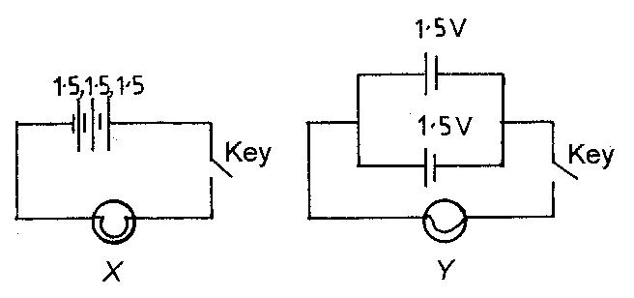

6. Which of the following statements is correct about the circuit diagrams above? The cells in diagram
A. X are in series and the key is open B. X are in parallel and the key is open
C. Y are in series and the key is closed D. Y are in parallel and the key is closed

7. The total emf of the cells in diagram Y is
A. 4.50 V B. 3.00 V C. 1.50 V D. 0.75 V

8. It is easier to move a heavy load with a crowbar when the
A. effort distance is shorter than the load distance B. effort distance is longer than the load distance
C. effort distance is equal to the load distance D. effort is equal to the load

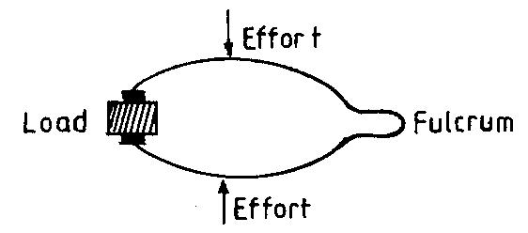

9. The type of lever shown above is a
A. first class lever B. second class lever
C. third class lever D. combination of first and second class levers

10. A balanced diet is one which is made up of
A. right proportions of protein, carbohydrates and oil B. equal amounts of protein, carbohydrates and oil
C. enough water and iodated salt D. vegetables, fruits and water
Pg 4
11. Benedict’s solution was added to a mixture in a test tube and it turned brick red when heated. The mixture is likely to contain
A. glucose B. oil C. protein D. vitamin

12. The main food substance present in the albumen of an egg is
A. carbohydrates B. fat C. protein D. vitamin

13. One characteristic which is not common to all living things is the ability to
A. grow B. move about C. respire D. respond to stimuli

14. The ovules in a flower develop to form the
A. fruit B. leaves C. seeds D. stem

15. Onions are planted by means of
A. bulbs B. corms C. suckers D. rhizomes

16. The testis in mammals produces
A. blood B. lymph C. sperms D. urine

17. Which of the following structures takes part in human digestion?
A. Caecum B. Kidney C. Larynx D. Pancreas

18. Which of the following diseases is contracted through sex?
A. HIV/AIDS B. Asthma C. Tuberculosis D. Goitre

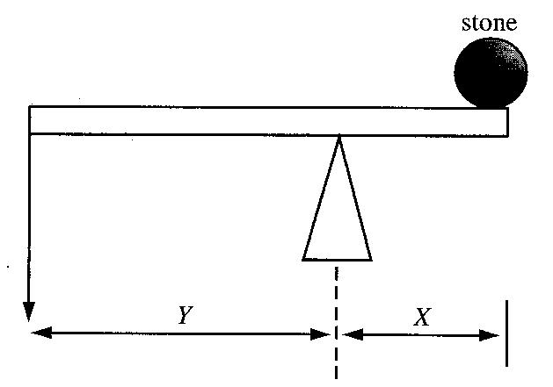
The diagram below shows a lever system used to move a stone. Use it to answer Questions 19 and 20.

19. The distance X is the
A. effort distance B. load distance C. fulcrum D. lever arm
20. Less effort is required to move the stone when the
A. distance Y is equal to X B. distance Y is greater than X
C. distance Y is less than X D. stone is at the pivot

21. The systematic name of the compound Fes is
A. iron (I) sulphide B. iron (II) sulphide C. iron (III) sulphide D. iron (IV) sulphide

22. Which of the following elements is a liquid at room temperature?
A. Carbon B. Mercury C. Silver D. Sulphur

23. The type of cloud that gives rain is
A. cumulus B. cirrus C. nimbus D. stratus

24. Water drains faster through sand than clay because
A. sand particles are rougher B. sand contains more air spaces
C. clay particles are smoother D. clay particles are bigger

25. Which of the following organisms is not an animal parasite?
Pg 5

A. tick B. tapeworm C. plasmodium D. weevil

26. The housefly is an agent for the spread of
A. cholera B. malaria C. measles D. tuberculosis

27. The best method for checking erosion on a slope is
A. cover cropping B. mixed cropping C. contour ploughing D. mulching

28. It is not advisable to sleep in a closed dark room with green plants because, the plants
A. produce heat B. compete with human beings for oxygen
C. absorb water vapour D. produce carbon dioxide

29. The process whereby soil is formed by the breakdown of rocks is called
A. composting B. erosion C. leaching D. weathering

30. Kerosene is able to reach the other end of a wick by
A. diffusion B. suction pressure C. capillary action D. osmosis

31. The force, which opposes the motion of one body on another body is called
A. adhesion B. cohesion C. friction D. tension

32. The work done when a force moves a body through a distance of 12 m is 720 J. The force applied is
A. 8640 N B. 732 N C. 708 N D. 60 N

33. Food substances are transported from the leaves to various parts of a plant through the
A. cambium B. epidermis C. phloem D. xylem

34. Which of the following substances are carried by the blood?
I. Nutrients
II. Urine
III. Oxygen
IV. Carbon dioxide

A. II and III only B. I, II and IV only C. I and III only D. I, III and IV only

35. A uniform mixture of two or more metals is called
A. an alloy B. a colloid C. an aerosol D. a compound

36. Gold is usually used to make jewellery because it is
A. precious B. expensive C. less reactive with air D. a good conductor of heat

37. Which of the following substances is a non-metal?
A. Diamond B. Mercury C. Sodium D. Steel

38. Alum is added to water during treatment to
A. kill germs B. help suspended particles to settle
C. make the water colourless D. give taste to the water

39. Which of the following types of water would be most contaminated by waste substances?
A. Rain water B. Stream water C. Bore hole water D. Pipe borne water

40. The method of preserving food by drying is similar to salting because in both cases germs are
A. deprived of the air needed for growth B. deprived of the water needed for growth
C. destroyed at high temperatures D. destroyed at low

Pg6

