35. Double clicking on a word in a word processing program selects the  
A. document B. paragraph C. sentence D. word

36. All of the following are reasons for using ICT in education except  
A. forcing students to learn at others’ pace  
B. increasing learner motivation and engagement  
C. facilitating the acquisition of basic skills in subject areas  
D. enhancing teaching through the use of presentation software

37. In word processing program, lines, block arrows and flow charts are found on which of the following toolbars?  
A. Drawing B. Formatting C. Picture D. Standard

38. Which program icon on the desktop leads to the disk drives  
A. Internet Explorer B. My Computer  
C. My Document D. My Network Places

39. Which of the following terms refers to unsolicited emails in the form of advertising or chain letters?  
A. Compose B. Inbox C. Spam D. Trash

40. Computer virus is capable of  
A. enhancing the contents of a file  
B. maintaining the computer system  
C. making the work of the computer easy  
D. slowing down the computer system performance

***END PAPER***

Pg 14

DE YOUNGSTER’S INTERNATIONAL SCHOOL

Name: ………………………………………………………………………….

Centre Number: ……………………………………………….……………….

Index: …………………………………………………………………………..

Paper Code: ……………………………………………………………………

Date: ……………………………………………………………………………

**INFORMATION AND COMMUNICATION TECHNOLOGY**

**2021 –MOCK 1**

PAPER 2 (Subjective) and Paper 1 (Objective)

DURATION: 1 Hour 15 MINS and 45 MINS

**INSTRUCTIONS**

Write your name and Index number in the space provided above.

Answer all the questions in the answer booklet provided.

Credit will be given to clarity of expression and orderly presentation of material.

**PAPER-2 (ESSAY)**

**ANSWER ALL QUESTIONS** IN THIS SECTION IN THE ANSWER BOOKLET PROVIDED.

**SECTION A** – ANSWER QUESTION 1 AS COMPULSORY QUESTION FOR **20 MARKS** AND CHOOSE ANY OTHER FOUR QUESTIONS IN SECTION B **FOR 40 MARKS**.

**SECTION A (PRACTICAL QUESTION)**

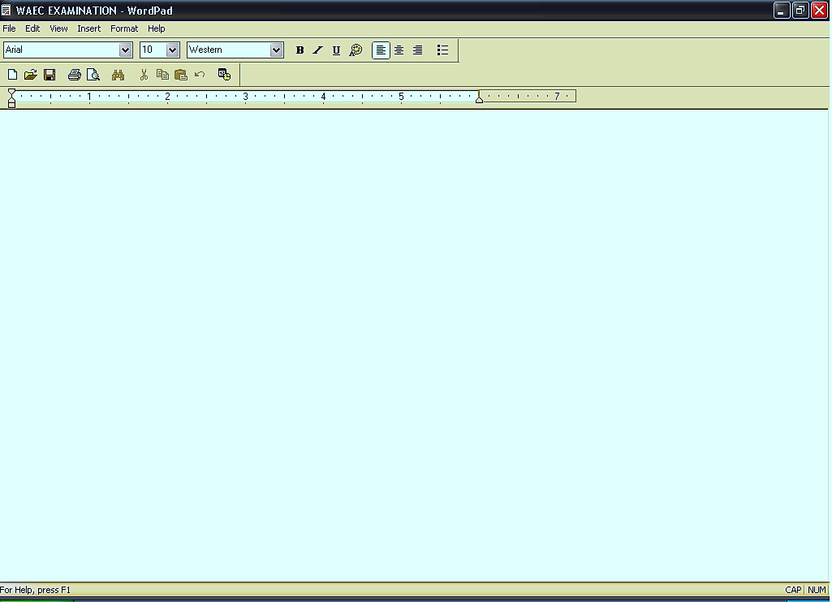

A

F

E

B

C

D

1**. a.** Study the diagram above carefully and answer the questions that follow:

(i) What is the name of the application program used to create the above file?

Pg 2

29. An entity in a file system which contains a group of files is called a  
A. cabinet B. container C. document D. folder

30. The creation of a copy of data on a computer system for safe keeping externally is referred to as  
A. data backup B. data entry

C. data filtering D. data restoration

31. The letter that normally represents the floppy disk in an operating system is  
A. A B. C C. D D. E

32. Recycle bin or trash bin contains deleted files and folders from the  
A. floppy disk B. flash disk C. hard disk  
D. zip disk

33. Keys on a computer keyboard which are used to move the cursor in a specified direction are called  
A. arrow keys  
B. function keys  
C. shift keys  
D. special purpose keys

34. To underline a selected text in a word processing program, the keys used are  
A. Ctrl + U B. Shift + U C. Alt + U D. Del + U

Pg 13

24. A program on the computer which enables users to type letters to friends is the  
A. browser  
B. spreadsheet  
C. utility  
D. word processor

25. The command that enables the user to save a previously saved document under a new name is  
A. new  
B. rename  
C. save  
D. save as

26. The standard toolbar contains buttons that  
A. close and resize windows  
B. control page margins and tabs  
C. perform the most common tasks  
D. help users to navigate through the document

27. To see exactly how the pages of a current document will appear when printed, the command given is the  
A. page setup command  
B. print command  
C. print preview command  
D. view command

28. A tool for locating information on the internet is the  
A. database engine B. internet browser C. search engine  
D. web browser

Pg 12

………………………………………....................................................................

(ii) Give the file name of the application above.

…………………………………………………………………………………….

(iii) Name the parts labeled A. B, C, D, E and F in the diagram

A………………………………………………………………………………………

B…………………………………………………………………………….………

C……………………………………………………………………………………

D……………………………………………………………………………………

E……………………………………………………………………………………

F…………………………………………………………………………………….

(iv) State the function of **B** and **C** in the diagram above.

B……………………………………………………………………………………

………………………………………………………………………………………

C……………………………………………………………………………………

………………………………………………………………………………………

**b.** List the steps (in the right order) involved in switching on a personal computer system.......................................................................................................................

……………………………………………………………………………………

……………………………………………………………………………………

………………………………………………………………………………………………………………………………………………………………………………………………………………………………………………………………………………………………………………………………………………………………………………………………………………………………………………………………………………………………………………………………………………

Pg 3

.……………………………………………………………………………………………………………………………………………………………………………………………………………………………………………………………………..

**c.** Identify the following ICT tools

**i. ii.**

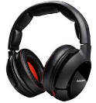……………………………...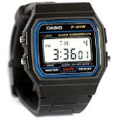…………………………



**iii**………………………………………………………

**SECTION B (EASSY TYPE QUESTIONS)**

**2.** State two differences between

**a.** a Ribbon and a Command tab

…………………………………………………………………………………………………………………………………………..................................................................................................................................................................................................................................................................................................................................................................................................................................................................................................................................

**b.** Hard disk and pen drive

............................................................................................................................................................................................................................................................................................................................................................................................................................................................................................................................................

**c.** File and folder

...............................................................................................................................................................................................................................................................................................................................................................................................................

Pg 4

18. The bar on the desktop which displays opened applications and other icons is referred to as  
A. scroll bar B. taskbar C. title bar D. toolbar

19. The act of pressing a computer mouse button twice quickly without moving the mouse is termed  
A. double clicking  
B. right clicking C. single clicking  
D. normal clicking

20. The following are good practices in the computing environment except  
A. copyrighting of software  
B. designing of cards  
C. networking of computers  
D. pirating of software

21. Which of the following software can be used to enhance teaching and learning through the use of pictures, video and sound?  
A. Multimedia software  
B. Network software  
C. Programming software  
D. Utility software

22. The total number of keys on a standard QWERTY keyboard is

A. 96 B. 104 C. 108 D. 116

23. Which of the following is a valid folder name?  
A. Black/Stars B. Black_Stars C. Black:Stars D. Black*

Pg11

13. To press the letter J, which finger is appropriate to use on a QWERTY keyboard?  
A. Left index finger B.Left middle finger

C. Right index finger D. Right middle finger

14. The internet is a  
A. global network of computers  
B. government agency that links computers  
C. software for designing programs  
D. special network of computers in an office

15. The computer equivalence of a sheet of paper divided into rows and columns in the office suite is called  
A. database  
B. electronic sheet  
C. spreadsheet  
D. word processor

16. The temporary working memory of a computer system is the  
A. arithmetic logic unit  
B. flash memory  
C. random access memory  
D. read only memory

17. The software responsible for the management of the basic operations of the computer is the  
A. application program  
B. device drivers  
C. operating system  
D. utility program

Pg 10

……………………………………………………………….. ................................................................................................................................3. State the use of the following email terminologies:

**a.** Carbon copy **b.** Blind carbon copy **c.** To; **d.** Subject

..................................................................................................................................................................................................................................................................................................................................................................................................................................................................................................................................................................................................................................................................................................................................................................................................................................................................................................................................................................................................................................................................................................................................................................................................................................................................................................................................................................................

4. **a**. The Home command tab contains seven (7) groups. Name them

………………………………………………………………………………………………………………….............

………………………………………………………………………………………………………………………………………………………………………………………………………………………………………………………………

…………………………………………………………………………………..............................................

………………………………………………………………………………………………………………………………………………………………………………………………………………………………………………………………

**b.** Explain the following commands as used in excel

|  |  |
| --- | --- |
| **I I 1. Autosum** |  |
| **2 2. Fill** |  |
| **S3 3. Clear** |  |
| **4.Sort & Filter** |  |
| **5. Find & Select** |  |

Pg 5

c. List two tools on the formatting toolbar of a word processing application.

………………………………………………………………………………………………………………………………………………………………………………………………………………………………………………………………………………………………………………………………………………………………………………………………………

5. a. What are the two basic requirements for composing and sending email messages?

……………………………………………………………………………………………………………………………………………………………………………………………………………………………………………………………………

b. What makes up the first part of the email address?

……………………………………………………………………………………………………………………………………………………………………………………………………………………………………………………………………

c. Describe the second part of the email address.

……………………………………………………………………………………………………………………………………………………………………………………………………………………………………………………………………

6. Explain the following terminologies in Microsoft office excel.

a. Rows b. Columns c. Cell d. Workbook e. Worksheet

………………………………………………………………………………………………………………………………………………………………………………………………………………………………………………………………………………………………………………………………………………………………………………………………………………………………………………………………………………………………………………………………………………………………………………………………………………………………………………………………………………………………………………………………………………………………………………………………………………………………………………………………………………………………………………………………………………………………………………………………………………………………………………………………………………………………………………………………………………………………………………………………………………………………………………………………………………………………………………………………………………………………………………………………………………………………………………………………………………………………………………………………………………………

Pg 6

6. Processed or transformed facts which are meaningful to the user is called  
A. data B. information C. input D. output

7. The following are possible health hazards of prolonged use of the computer system except  
A. back and neck pains B. eye strain C. tuberculosis  
D. wrist pains

8. Which key on the keyboard is used to erase characters from right to left in word processing application?  
A. Backspace B. Delete C. Insert D. Pause

9. The key on the QWERTY keyboard used to produce alphabetic upper case letters is  
A. Caps Lock B. Home C. Num Lock D. Tab

10. Given sizes and designs of letters, numbers and symbols that are displayed in a word processing document are referred to as  
A. align B. bullet C. font D. indent

11. Which of the following is a tool on the drawing toolbar of a word processing program?  
A. Align B. Bold C. View D. Oval

12. When an image is copied, it first goes to the  
A. clip art  
B. clipboard  
C. my document  
D. recycle bin

Pg 9

OBJECTIVE TEST (PAPER 1)

1. The device that converts computer output into displayed images is the  
A. hard disk B. monitor C. printer D. processor

2. The least number of input devices that a computer system can have is  
A. 1 B. 2 C. 3 D. 4

3. Which of the following devices has the largest storage capacity  
A. Compact disc  
B. Digital versatile disc  
C. Floppy disk  
D. Hard disk

4. The device used to ensure a constant flow of power supply to a computer system is the  
A. stabilizer  
B. step-down transformer  
C. step-up transformer  
D. uninterruptible power supply

5. The total number of command buttons on the title bar of an opened word processing window is  
A. 2 B. 3 C. 5 D. 6

Pg8

……………………………………………………………………………………………………………………………………………………………………………………………………………………………………………………………………………………………………………………………………………………………………………………………………………………………………………………………………………………………………………………………………………………………………………………………………………………………………………………………………………………………………………………………………………………………………………………………………………………………………………………………………………………………………………………………………………………………………………………............................................................................

***END OF ESSAY TEST***

Pg 7

DO NOT TURN TO THE NEXT PAGE UNTIL YOU ARE TOLD TO DO SO.